**Lab 1: Object-oriented Programming**

**Instruction**

1. Click the provided link on CourseVille to create your own repository.
2. Open Eclipse and then “File > new > Java Project” and set project name in this format **2110215_Lab1_2021_2_{ID}_{FIRSTNAME}**
   * Example: **2110215_Lab1_2021_2_6131234521_Samatcha**.
3. Initialize git in your project directory
   * Add .gitignore.
   * Commit and push initial codes to your GitHub repository.
4. Implement all the classes and methods following the details given in the problem (some files or part of the files are already given, please see the src folder in the given file) statement file which you can download from CourseVille.
   * You should create commits with meaningful messages when you finish each part of your program.
   * Don’t wait until you finish all features to create a commit.
5. Test your codes with the provided JUnit test cases, they are inside package **test.grader**
   * If you want to create your own test cases, please put them inside package **test.student**
   * Aside from passing all test cases, your program must be able to run properly without any runtime errors.
6. After finishing the program, create a UML diagram and put the result image (UML.png) at the root of your project folder.
7. Export your project into a jar file called **Lab1_2021_2_{ID}** and place it at the root directory of your project.
   * Example: **Lab1_2021_2_6131234521.jar**
8. Push all other commits to your GitHub repository

**1. Problem Statement: Card Game Deck Manager**

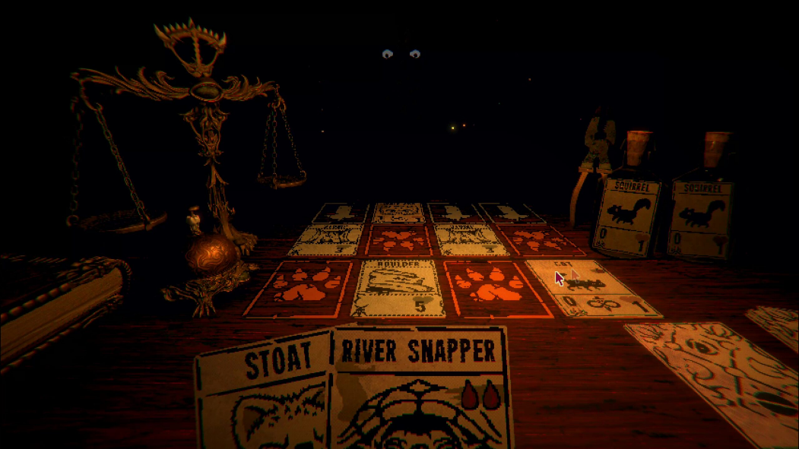

(This exercise is based on the game Inscryption by Daniel Mullins Games, released in October 2021.)

A strange, mysterious being has captured you and asked you to play a card game with him. In order to plan your cards and decks, you intend to create a deck manager program to keep things organized in order to have a fighting chance against the mysterious dealer.

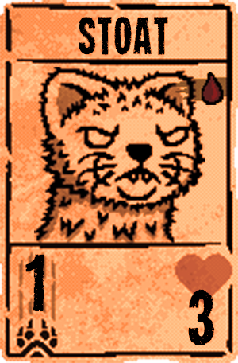

This is an example card, a Stoat with 1 power and 3 health. It costs 1 blood to play. Each card has the following properties:

1. The card’s name
2. The card’s Blood Cost[1] (how many other creatures must be sacrificed to summon this card)
3. The card’s power (the damage it will deal)
4. The card’s health (if it reaches 0, then the creature will die)

On startup, this is how the program will look like. There are 9 options you can choose to do in this program.

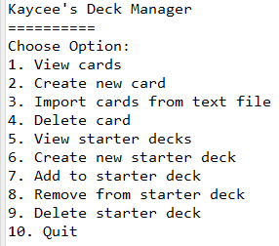

1. View cards: View the cards that are available to you.  
   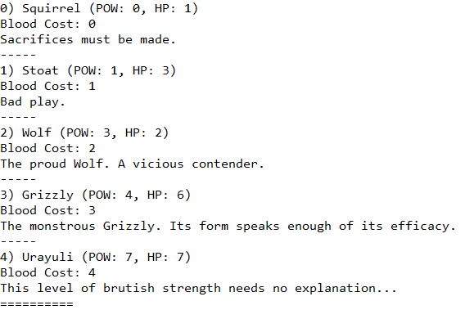
2. Create new card: Define a new card that you can use to add to your decks.  
   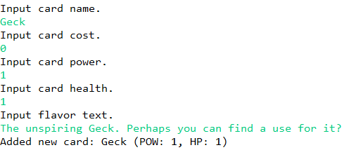
3. Import cards from text file: Adds multiple new cards at a time. Put in the name of a text file that exists in the project folder, and it will add any cards that don’t exist yet to the collection.  
   

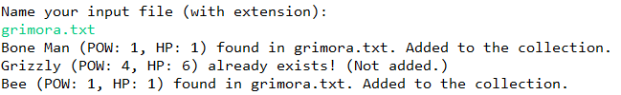

1. Delete card: Remove a card from your list of cards. Note that you cannot delete any cards that are still in any decks.  
   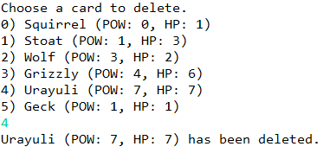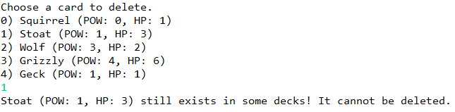
2. View starter decks: View decks that you have arranged. Each deck will have a certain number of each card in it.  
   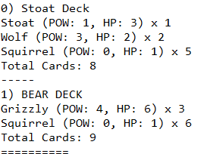
3. Create new starter deck: Creates a new empty deck that you can place cards in. You cannot use duplicate names.  
   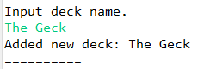  
   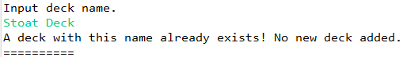
4. Add to starter deck: Adds cards to a starter deck of your choice.  
   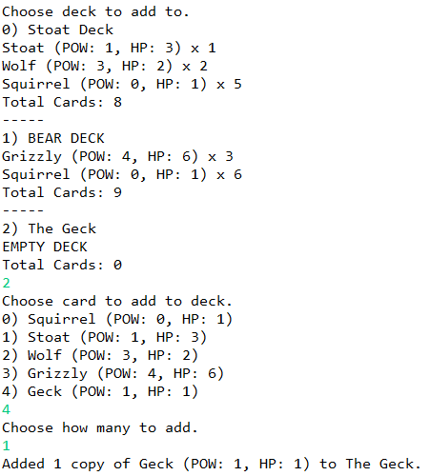
5. Remove from starter deck: Removes cards from a starter deck of your choice. You can only remove cards from a deck if there is at least 1 copy of that card in the deck.  
   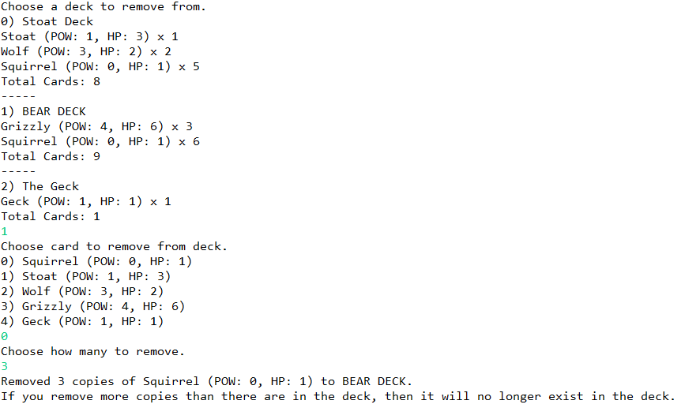  
   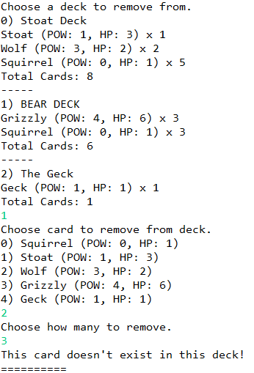
6. Delete starter deck: Deletes a deck from your collection.  
   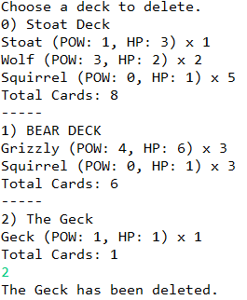

# 2. Implementation Details:

The diagram of the program is illustrated below. There are 5 classes: UnitDeck, CardCounter, UnitCard, CardUtil, and DeckManager.

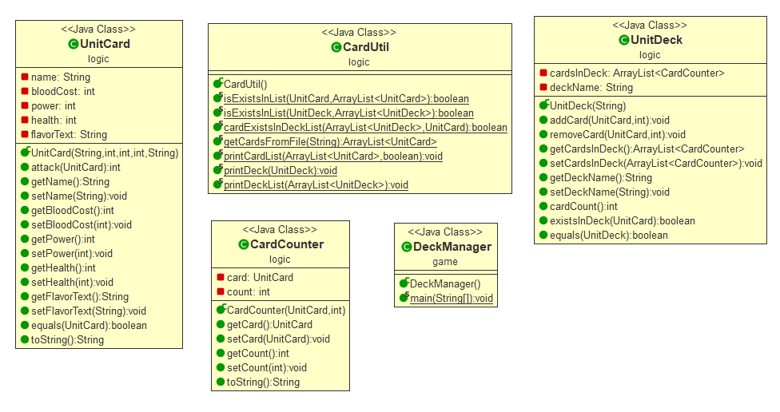

*\* Note that Access Modifier Notations can be listed below*

*\* Also note that while other methods have been provided, only methods that you have to implement are listed here*

***+ (public)***

***# (protected)***

***- (private)***

## 2.1 Class UnitCard (package logic)

This class represents a card in the collection. Each card has a name, some properties, and a flavor text.

### 2.1.1 Fields

|  |  |
| --- | --- |
| - String name | The name of this card. It cannot be blank. |
| - int bloodCost | The blood cost required to summon this card. It cannot be less than 0. |
| - int power | The card’s base power. It cannot be less than 0. |
| - int health | The card’s base health. It cannot be less than 1. |
| - String flavorText | The card’s flavor text. |

### 2.1.2 Constructors

|  |  |
| --- | --- |
| + UnitCard(String name, int bloodCost, int power, int health, String flavorText) | **/*Fill Code*/**  Initialize **all fields**.  **Note: You should use setter to set the value of all fields in order to handle negative value cases and special cases.** |

### 2.1.3 Methods

|  |  |
| --- | --- |
| + void setName(String name) | **/*Fill Code*/**  This method will set name of the card. If the String is empty, the method will set the name as “Creature”.  **Hint: There is a non-static method called isBlank() in the String class. It returns true if a String consists of only whitespace.**  **Example:**  **String exampleString = “ “;**  **exampleString.isBlank() will return true.** |
| + void setBloodCost(int bloodCost) | **/*Fill Code*/**  This method will set the blood cost of the card. If the blood cost is less than 0, it will be set as 0. |
| + void setPower(int power) | **/*Fill Code*/**  This method will set the power of the card. If the power is less than 0, it will be set as 0. |
| + void setHealth(int health) | This method will set the health of the card. If the health is less than 1, it will be set as 1. |
| + boolean equals(UnitCard other) | **/*Fill Code*/**  This method checks if this card is the same as the other given card. To qualify as the same card, both cards must have the same name. Please note that the type of method parameter is UnitCard. This method is designed for testing only UnitCard against one another. |
| + String toString() | Returns the object as a string. |
| Getter & Setter methods for all other variables | **/*Fill Code*/** |

# 2.2 Class CardCounter (package logic)

This class is an object that is used to count cards in a deck. For each CardCounter object, there is a Card that is being counted, and the number of that card that exists in a deck.

### 2.2.1 Fields

|  |  |
| --- | --- |
| - UnitCard card | The card being counted by this counter. |
| - int count | The number of cards being counted by this counter. It cannot be less than 0. |

### 2.2.2 Constructors

|  |  |
| --- | --- |
| + CardCounter(UnitCard card, int count) | **/*Fill Code*/**  Initialize **all fields**.  **Note: You should use setter to set the value of all fields in order to handle negative value cases and special cases.** |

### 2.2.3 Methods

|  |  |
| --- | --- |
| + void setCount(int count) | **/*Fill Code*/**  This method will set the count of the card counter. If the count is less than 0, it will be set as 0. |
| + String toString() | Returns the object as a string. |
| Getter & Setter methods for all other variables | **/*Fill Code*/** |

# 2.3 Class UnitDeck (package logic)

This card represents a deck in your collection. Each deck will have some amount of Card Counter to represent the cards in the deck, and the count of each card in the deck.

**/*You need to write this entire class from scratch. */**

### 2.3.1 Fields

|  |  |
| --- | --- |
| - ArrayList<CardCounter> cardsInDeck | The list of Card Counters that counts the number of each card type in the deck. |
| - String deckName | The name of this deck. It cannot be blank. |

### 2.3.2 Constructors

|  |  |
| --- | --- |
| + UnitDeck(String deckName) | **/*Fill Code*/**  Initialize cardsInDeck as an empty ArrayList. Also, initialize the deck name.  Don’t forget to use the proper getter/setter to handle special cases. |

### 2.3.3 Methods

|  |  |
| --- | --- |
| + void addCard(UnitCard newCard, int count) | **/*Fill Code*/**  This method adds new cards to the deck, equal to the given number. If the given count is not a positive integer, then it does nothing.  If this card already exists in the deck, it adds the count to the CardCounter corresponding to the pre-existing card in cardsInDeck.  If this card does **NOT** already exist in the deck, then initialize a new CardCounter corresponding to this card with the given count, then add it to cardsInDeck. |
| + void removeCard(UnitCard toRemove, int count) | **/*Fill Code*/**  This method removes cards from the deck, equal to the given number. If the given count is not a positive integer or if the given card doesn’t exist in the deck, then it does nothing.  If this card exists in the deck, it decreases the count from the CardCounter of this existing card in cardsInDeck according to the method’s count parameter.  If the count reaches 0 this way, then the CardCounter must also be removed from cardsInDeck. |
| + int cardCount() | **/*Fill Code*/**  This method counts the number of cards in this deck. The number of cards is the total sum of each CardCounter’s count in cardsInDeck. |
| + boolean existsInDeck(UnitCard card) | **/*Fill Code*/**  This method checks if the given card exists in this deck. The card exists in the deck if there is a CardCounter with a count of 1 or greater in cardsInDeck. |
| + boolean equals(UnitDeck other) | **/*Fill Code*/**  This method checks if this deck is the same as the other given deck. To qualify as the same deck, both decks must have the same name.  Please note that the type of method parameter is UnitDeck. This method is designed for testing only UnitDeck against one another. |
| Getter & Setter methods for deckName and cardsInDeck. | **/*Fill Code*/**  deckName cannot be empty. If the given deckName is empty, then set the deckName as “Untitled Deck”.  **Hint: There is a non-static method called isBlank() in the String class. It returns true if a String consists of only whitespace.**  **Example:**  **String exampleString = “ “;**  **exampleString.isBlank() will return true.** |

# 2.4 Class CardUtil (package logic)

This class contains static utility methods that are useful in one or more classes. Most of these have to do with manipulating cards and decks.

### 2.4.1 Fields

This class only contains static methods and do not have any fields.

### 2.4.2 Constructors

This class does not need a constructor.

### 2.4.3 Methods

|  |  |
| --- | --- |
| + boolean isExistsInList(UnitCard card, ArrayList<UnitCard> list) | **/*Fill Code*/** This method checks if the given card exists in the given ArrayList. Return true if it does, return false otherwise. |
| + boolean isExistsInList(UnitDeck deck, ArrayList<UnitDeck> list) | **/*Fill Code*/**  This method checks if the given deck exists in the given ArrayList. Return true if it does, return false otherwise. |
| + boolean cardExistsInDeckList(ArrayList<UnitDeck> deckList, UnitCard cardToTest) | **/*Fill Code*/**  This method checks if the given deckList contains any CardCounter with the given UnitCard in it. Return true if it does, return false otherwise. |
| + ArrayList<UnitCard> getCardsFromFile(String filename) | **/*Fill Code*/**  Three lines of this function has been given to you. Replace “//TODO: Fill Code” with the following algorithm:  First, create a scanner to read fileToRead.  Then, while the scanner still has lines for it to read, get the string of the line. Split it with comma to get an array, and create a new card like this:   * The 0th member of the array is the Card Name. * The 1st member of the array is the Blood Cost. * The 2nd member of the array is the Power. * The 3rd member of the array is the Health. * The 4th member of the array is the Flavor Text.   Finally, return the list of all cards created this way. Don’t forget to close the scanner as well! If the file is not found or if there is error while reading the file (for example, the text file isn’t properly formatted), this method should return null instead.  Hint: You might need to use try catch or throw exceptions here.  IMPORTANT: There is no JUnit test for this method. Your program must be able to read a card file during its actual use. |
| + void printCardList(ArrayList<UnitCard> cardList, boolean verbose) | Prints a list of cards as formatted string. If verbose is set to true, it prints the flavor text as well. |
| + void printDeck(UnitDeck ud) | Prints the list of cards in the deck as a formatted string list of CardCounters. |
| + static void printDeckList(ArrayList<UnitDeck> deckList) | Prints all the decks in the given list as formatted string. |

# 2.5 Class DeckManager (package game)

This is the class where you can run the deck manager from.

# 3. Test Scenario

(User input is in green.)

Since other methods can be tested in the JUnit, we will only display how to test the card import function here. In order to test the import function, we have provided two text files. The file “grimora.txt” contains correctly formatted string, while “badtext.txt” contains incorrectly formatted string. We will also attempt to read “nonexist.txt”, which does not exist in the project folder.

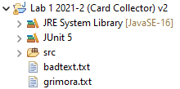

This is the current state of the project, with the two mentioned text files. Note that “nonexist.txt” does not exist.

The file “grimora.txt” looks like this.



Note that if this file is imported, Bone Man and Bee should be added since they don’t already exist, and Grizzly should not be added since it already exists in the program’s initial state.

The file “badtext.txt” looks like this.

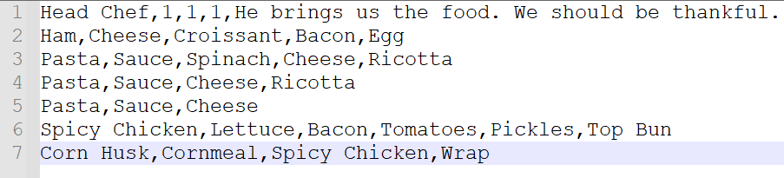

Since this would result in an error, importing this file should not add any new cards at all. Head Chef should not exist in your collection after importing cards from this text file.

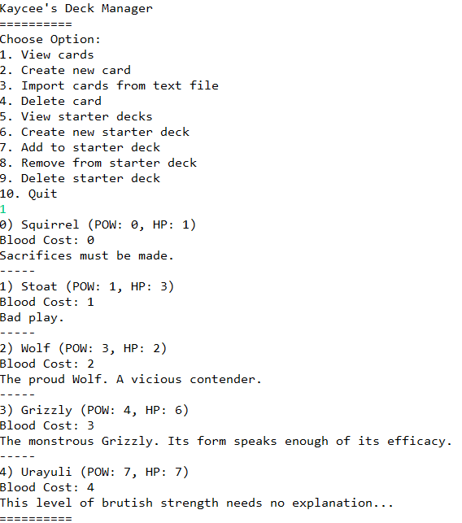

Here, we test the initial state of the card collection. **Note that the Grizzly exists so it should not be added when imported.**

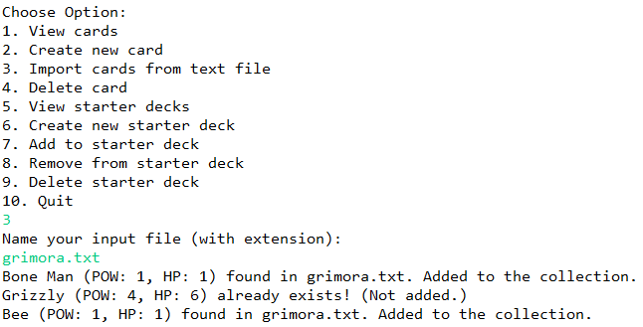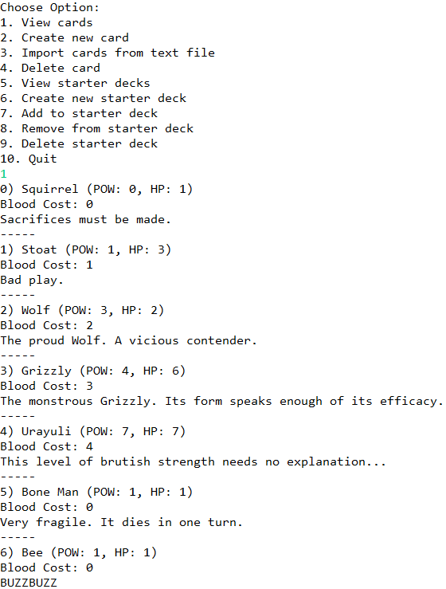

This is what happens if you import a valid text file. This step tests if your function is able to properly read imported text files. **Note that the Grizzly does not appear twice.**

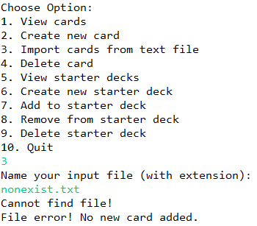  
This is what happens if you import a text file that does not exist. This step tests if your function can handle non-existent files. **No new cards should be added.**

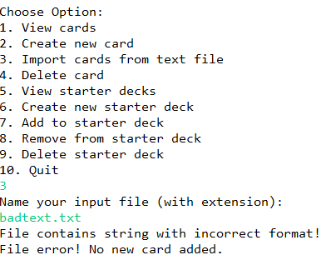



The following card should not exist:

7) Head Chef (POW: 1, HP: 1)

Blood Cost: 1

He brings us the food. We should be thankful.

This is what happens if you import a text file with bad string format. This step tests if your function can handle files with incorrect format. **Note that no new cards are added at all, even if the first line in the text file is valid.**

# 4. Criteria

There is a total of 37 points to be gained. This will be factored to a max score of 5.

## 4.1 JUnit

### UnitCardTest

* testConstructor (2)
* testBadConstructor (2)
* testSetName (1)
* testSetBloodCost (1)
* testSetPower (1)
* testSetHealth (1)
* testEquals (1)

### CardCounterTest

* testConstructor (2)
* testBadConstructor (2)
* testSetCount (1)

### UnitDeckTest

* testConstructor (2)
* testBadConstructor (2)
* testSetName (1)
* testAddCardNonExist (1)
* testAddCardExist (1)
* testRemoveNonExistingCard (1)
* testRemoveExistingCard (1)
* testCardCount (1)
* testExistsInDeck (1)
* testEquals (1)

### CardUtilTest

* testIsExistsInListCard (1)
* testIsExistsInListDeck (1)
* testCardExistsInDeckList (1)

## 4.2 Exception (getCardsFromFile Functionality)

### File With Valid String Format

* New cards are added (1)
* Cards that already exist aren’t added (1)

### File With Invalid String Format

* The program shows error message and can continue running (1)
* No new cards are added (1)

### File That Doesn’t Exist

* The program shows error message and can continue running (1)
* No new cards are added (1)

## 4.3 UML

* An image file of a correct UML diagram exists in the root of the project (2)

1. If you played the game before, you might know some cards cost Bones to play instead, we will ignore those cards for now. Sigils will also be ignored for now.